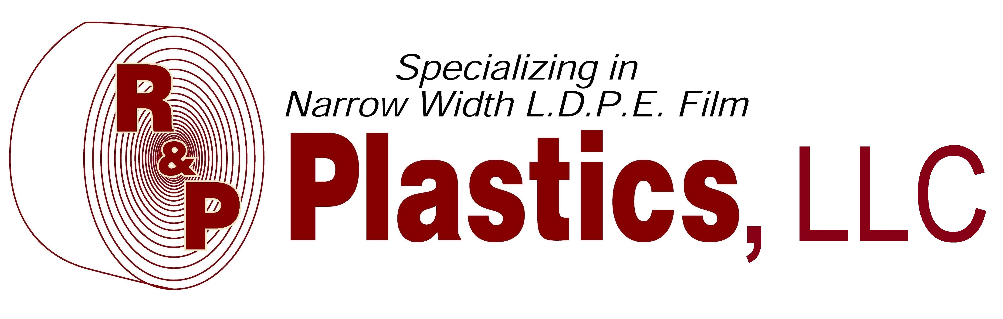

We are pleased to announce that we have extended our product line to include the following using blends of LDPE and LLDPE:
- Film sizes from 1” to 40” layflat
- Sheeting to 40” - DWS AND SWS
- C-Fold from 3” to 40”
- J-Films
- Layflat bags 3” to 38” wide
- Gusseted bags 8” to 45” total inside dimension
- Star seal bags
- B.O.R. or Individual bags
- Various colors and additives
- FDA approved products available upon request

NOTE:
This is a list of our most common products, however it is not everything we are capable of producing. Please contact us if you need assistance with a product not listed above.
Thank you!

